Java Architecture

Java Architecture is a collection of components, i.e., JVM, JRE, and JDK. It integrates the process of interpretation and compilation. It defines all the processes involved in creating a Java program.It defines all the processes involved in creating a Java program. Java Architecture explains each and every step of how a program is compiled and executed.Java Architecture can be explained by using the following steps:

There is a process of compilation and interpretation in Java.

Java compiler converts the Java code into byte code.

After that, the JVM converts the byte code into machine code.

The machine code is then executed by the machine.

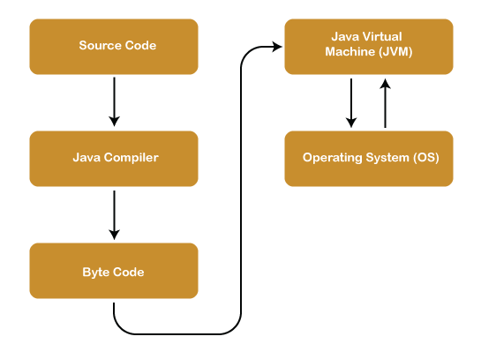

Components of Java Architecture

The Java architecture includes the three main components:

* Java Virtual Machine (JVM)
* Java Runtime Environment (JRE)
* Java Development Kit (JDK)

### **Java Virtual Machine**

The main feature of Java is **WORA**. WORA stands for **Write Once Run Anywhere**. The feature states that we can write our code once and use it anywhere or on any operating system. Our Java program can run any of the platforms only because of the Java Virtual Machine. It is a Java platform component that gives us an environment to execute java programs. JVM's main task is to convert byte code into machine code.

JVM, first of all, loads the code into memory and verifies it. After that, it executes the code and provides a runtime environment. [Java Virtual Machine (JVM)](https://www.javatpoint.com/jvm-java-virtual-machine)

has its own architecture, which is given below:

**JVM Architecture**

JVM is an abstract machine that provides the environment in which Java bytecode is executed. The falling figure represents the architecture of the JVM.

### **Java Runtime Environment**

It provides an environment in which Java programs are executed. JRE takes our Java code, integrates it with the required libraries, and then starts the JVM to execute it. To learn more about the Java Runtime Environment, [click here](https://www.javatpoint.com/java-jre)

.

### **Java Development Kit**

It is a software development environment used in the development of Java applications and applets. Java Development Kit holds JRE, a compiler, an interpreter or loader, and several development tools in it. To learn more about the Java Development Kit.

These are three main components of Java Architecture. The execution of a program is done with all these three components.